6.32: The work you do with your changing force is
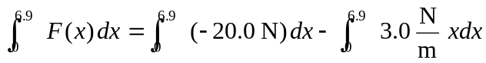
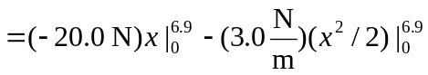

The work is negative because the cow continues to advance as you vainly attempt to push her backward.

